# TITLE OF PAPER (style heading 1: font formats - times new roman, 12 pt bold, ALL CAPS; paragraph formats: centered, spacing before 30 pt, spacing after 0 pt, keep with next, KEEP LINES TOGETHER)

UDC (12pt italic, centered, spacing before 6 pt, spacing after 30 pt,   
keep with next, this line will be written by the journal)

## Name Surname1, Name Surname2, … (Style Heading 2: 12 pt bold, title case, centered, spacing before 0 pt, spacing after 12 pt, keep with next, keep lines together; write full name and full surname)

1Affiliation (Style Affiliation: 10pt, centered, spacing before 0 pt, after 18 pt, keep with next; only affiliation, no postal address, no email-address)

2Affiliation (Style Affiliation; **only if affiliation differs; use superscript only if needed**)

**Abstract (bold)**. Short abstract (Style Abstract: 9 pt, italic, pt, justified, 0.75 pt left and right indentation).

**Key words** **(bold)**: key word 1, key word 2... to (max) key word 6

### 1. Main heading (Style Heading 3: small caps 10 pt, centered, spacing before 24 pt, spacing after 6 pt, keep with next, keep lines together)

**Important:** The predefined styles are to be used. All parts of the manuscript (title, authors, affiliations, abstract, keywords, subtitles, text, figures, figure titles, tables, table titles, equations, references, etc.) must use the suitable style. The styles are described here, but they are available in this file, in the list of styles. The styles define the spacing to surrounding manuscript elements (before and after) and, hence, **empty lines should not be inserted**. The authors should be aware that the failure to use the proper styles and therewith to properly format the manuscript would postpone processing of the submission.

**Main text**: only use characters and symbols available in the Times New Roman or Symbol font (as in the full text of paper), 10 pt; paragraph format: justified alignment, left and right indent 0 pt, space before and after 0 pt, first line indent 0.5 cm. An Equation Editor is to be used in the main text only if symbols are needed (when explaining terms from equations, for instance) that are not available as plain text or symbols.

#### 1.1. Subheading (Style Heading 4: 10 pt, bold, left, indentation left 5 pt, spacing before 12 pt, after 6 pt, keep with next, keep lines together)

Sample of main text. Sample of main text. Sample of main text. Sample of main text. Sample of main text. Sample of main text. Sample of main text. Sample of main text. Sample of main text. Sample of main text. Sample of main text. Sample of main text. Sample of main text. Sample of main text. Sample of main text. Sample of main text. Sample of main text. Sample of main text. Sample of main text. Sample of main text. Sample of main text. Sample of main text. Sample of main text. Sample of main text.

##### 1.1. Subheading (Style Heading 5: 10 pt, italic, left, indentation left 5 pt, spacing before 12 pt, after 6pt, keep with next, keep lines together)

Sample of main text. Sample of main text. Sample of main text. Sample of main text. Sample of main text. Sample of main text. Sample of main text. Sample of main text. Sample of main text. Sample of main text. Sample of main text. Sample of main text.

**Equations** should be prepared using the MathType Equation Editor (preferred) or an Equation Editor integrated in Word, with styles and sizes as defined in Fig. 1. **Important: The authors should avoid using an Equation Editor directly in the text (e.g. when they explain terms/quantities used in the equations). Plain text and symbols () should be used instead.** Only if no adequate symbols are available, an Equation Editor is to be used directly in the text..

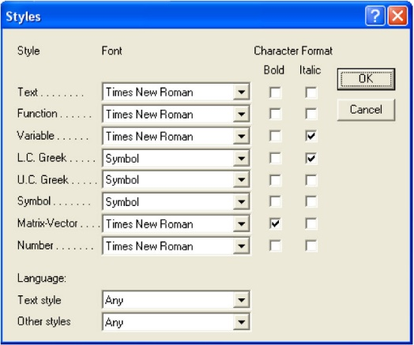 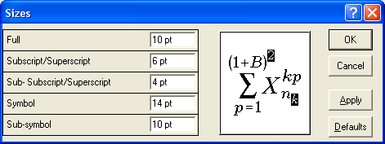

Fig. 1 Title of figure

 (1)

Paragraph format for equations is (Style Equation): left indentation, 6 pt before and after, equation is at position of centered tab at 6.25 cm, number of equation is at position of right tab at 12.7 cm. Refer to equations in the text as Eq. (1), or Eqs. (1) and (2), and similar.

**The file may be saved as .doc or .docx file. Please note that equations must be editable, i.e. they cannot be given as figures.**

#### Illustrations: figures, photographs, line drawings, graphs (Styles Figure and Figure Title)

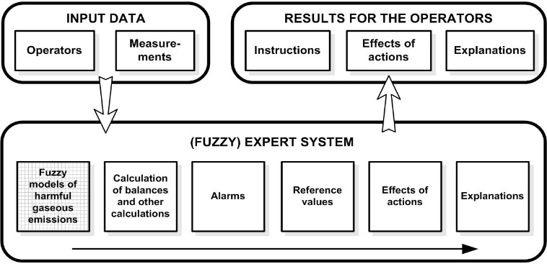

Fig. 2 Title of figure

**All illustrations (figures, photographs, line drawings, graphs)** should be numbered in series and all legends should be included at the bottom of each illustration. All **figures,** **photographs,** **line drawings and graphs,** prepared in electronic form, should be converted in TIFF or JPG (max quality) files, in 300 dpi resolution, for superior repro­duction. Figures, line drawings and graphs prepared using elements of MS Drawing or MS Graph must be converted in form of pictures and unchangeable. All illustrations should be planned in advance so as to allow reduction to 12.75 cm in column width. Please review all illustrations to ensure that they are readable. Refer to figures in the text as Fig. 1, or Figs. 1 and 2, and similar.

#### Tables

Table 1 Title of table (Style Table title)

|  |  |
| --- | --- |
| System | Symbol |
| Without delay | + |
| Delay *h* = 1 | − |
| Delay *h* = *N* = 34 | * |

All tables should be numbered with consecutive Arabic numbers. They should have descriptive captions at the top of each table and should be mentioned in the text.

**Acknowledgement**: The paper is a part of the research done within the project 1234567890. The authors would like to thank to the... (Style Acknowledgement).

### References (Samples for Serial, Book, Proceeding, Thesis, Patent - *Style Reference*)

Goroško Oleg Aleksandrovič and Katica (Stevanović) Hedrih, (2001), *Analitička dinamika (mehanika) diskretnih naslednih sistema, (Analytical Dynamics (Mechanics) of Discrete Hereditary Systems)*, University of Niš, 1999-2000-2001, p. 426.

Hedrih (Stevanović) K., (2001), *Vector Method of the Heavy Rotor Kinetic Parameter Analysis and Nonlinear Dynamics*, University of Niš 2001, Monograph, p. 252. **YU ISBN 86-7181-046-1 UDC 531.38:514.742.4**

Hedrih (Stevanović) K., A Trigger of Coupled Singularities, ***MECCANICA***, **Vol.39, No. 3, 2004., pp. 295-314**. International Journal of the Italian Association of Theoretical and Applied Мechanics, **Springer**

**Hedrih (Stevanović) K.,The Dissipation Function of a Nonconservative System of Mass Particles, *Tensor,* N.S.,Vol.63, No.2(2002), pp.176-186.**  Tensor Society , Japan . ISSN 0040-3504.

**Hedrih (Stevanović) K., (2006),** Transversal Vibrations of Double-Plate Systems, ***Acta Mechanica Sinica, Springer*,** (2006) 22, pp. 487-501 **(hard cower and on line).**

Katica (Stevanović) Hedrih, (2006), The frequency equation theorems of small oscillations of a hybrid system containing coupled discrete and continuous subsystems, *Facta Universitatis, Series Mechanics, Automatic Control and Robotics*, Vol.5, No 1, 2006 pp. 25 - 41 ; <http://facta.junis.ni.ac.yu/facta/>

Hedrih (Stevanovi**ć**) K., (2006), Transversal Vibration of a Parametrically Excited Beam: Influence of Rotatory Inertia and Transverse Shear on Stochastic Stability of Deformable Forms and Processes, ©Freund Publishing House Ltd. *International Journal of* *Nonlinear Sciences and Numerical Simulation*, 7(1), 117-124, 2006.

Hedrih (Stevanović), K., (2007), Energy analysis in the nonlinear hybrid system containing linear and nonlinear  subsystem coupled by hereditary element, *Nonlinear Dynamics*, Springer, (corrected proof, in press) DOI 10.1007/s11071-007-9197-2

Hedrih (Stevanović) K., (2006), Modes of the Homogeneous Chain Dynamics, *Signal Processing*, Elsevier, 86(2006), 2678-2702.. ISSN: 0165-1684 [www.sciencedirect.com/science/journal/01651684](http://www.sciencedirect.com/science/journal/01651684)

Hedrih (Stevanović) K., (2005), Partial Fractional Order Differential Equations of Transversal Vibrations of Creep-connected Double Plate Systems, in Monograph - Fractional Differentiation and its Applications, Edited by Alain Le Mahaute, J. A. Tenreiro Machado, Jean Claude Trigeassou and Jocelyn Sabatier, U-Book, pp. 289-302.

Hedrih (Stevanović) K., (2005), Nonlinear Dynamics of a Heavy Material Particle Along Circle which Rotates and Optimal Control, *Chaotic Dynamics and Control of Systems and Processes in Mechanics* (Eds: G. Rega, and F. Vestroni), p. 37-45. IUTAM Book, **in Series *Solid Mechanics and Its Applications***, **Editerd by G.M.L. Gladwell, Springer**,. 2005, XXVI, 504 p., Hardcover ISBN: 1-4020-3267-6.

Hedrih (Stevanović) K., (2005), Homoclinic Orbits Layering in the Coupled Rotor Nonlinear Dynamics and Chaotic Clock Models, SM17 – Multibody Dynamics (M. Geraldin and F. Pfeiffer), p. Lxiii – CD - SM10624, *Mechanics of the 21st Century (21st ICTAM, Warsaw 2004)* - CD ROM INCLUDED, edited by Witold Gutkowski and Tomasz A. Kowalewski, IUTAM, Springer 2005, ISBN 1-4020-3456-3, Hardcover., p. 421+CD. ISBN-13 978-1-4020-3456-5 (HB), ISBN-10 1-4020-3559-4(e-book), ISBN-13-978-1-4020-3559-3

Hedrih (Stevanović) K., (2004), Partial fractional order differential equations of transversal vibrations of creep connected double plate systems, *Workshop Preprints/Proceedings* No 2004-1 IFAC FDA 04, ENSEIRB, Bordeaux France, July 19-21, 2004., pp. 299-304.

**Hedrih (Stevanović) K., Vukota Babović, Dragan Šarković, (2006), An auxi liary size distribution model for the ultrasonically produced water droplets, *Experimental Thermal and Fluid Science*, Elsevier**, Volume 30, Issue 6, June 2006, Pages 559-564 <http://www.elsevier.com/locate/etfs>

Janković, V. S., Potić, V. P. and Hedrih (Stevanović), K., Parcijalne diferencijalne jednačine i integralne jednačine sa primenama u inženjerstvu (Partial differential equations and integro-differential equations with examples in engineering), Univerzitet u Nišu, 1999, str. 347. (in Serbian)

Mitropolskiy Yu.A. and Moseenkov B.I.,(1976), *Asymptotic solutions of the Partial Differential Equations*, Kiev 1976. (in Russian)

Nestorović Trajkov T., Köppe H., Gabbert U.: Vibration control of a funnel-shaped shell structure with distributed piezoelectric actuators and sensors, *Smart Materials and Structures*, 15, pp. 1119-1132, doi:10.1088/0964-1726/15/4/026, <http://www.iop.org/EJ/abstract/0964-1726/15/4/026/>