
ORIGINAL SCIENTIFIC PAPER
https://doi.org/xxxxxxxxxy

TITLE OF PAPER (style heading 1: font formats - times new roman, 12 pt bold, ALL CAPS; paragraph formats: centered, spacing before 18 pt, spacing after 18 pt, keep with next, KEEP LINES TOGETHER)

Name Surname¹, Name Surname², … (Style Heading 2: 12 pt bold, title case, centered, spacing before 0 pt, spacing after 12 pt, keep with next, keep lines together; write full name and full surname)
¹Affiliation (Style Affiliation: 10 pt, centered, spacing before 0 pt, after 12 pt, keep with next; only affiliation, no postal address, with e-mail address)
²Affiliation (Style Affiliation; only if affiliation differs; use superscript only if needed)
ORCID iDs: Name Surname1 https://orcid.org/xxxx-xxxx-xxxx-xxxx
Name Surname2 https://orcid.org/xxxx-xxxx-xxxx-xxxx
Name Surname3 https://orcid.org/xxxx-xxxx-xxxx-xxxx
Name Surname4 https://orcid.org/xxxx-xxxx-xxxx-xxxx

Abstract. Short abstract (Style Abstract: 9 pt, italic, justified). Manuscript typing instructions for authors provide the information about the styles for preparation of the manuscripts that will be submitted to the 29th International Conference “Noise and Vibration”. Your manuscript must be typewritten taking this page as an example, using computed-edited text program Word for Windows. Use only document Instructions2026.docx with predefined styles for typewritten manuscript. This document can be load from
https://www.znrfak.ni.ac.rs/NOISE2026/Guidelines.html.
The manuscript must be written in English and should not exceed 8 pages in A4 format including figures, tables, references and illustrations. The electronic form of the manuscript (Word and PDF version) should be submitted to the Conference Secretariat by e-mail no later than September 1, 2026:
darko.mihajlov@znrfak.ni.ac.rs
petar.jovanovic@znrfak.ni.ac.rs
Key words: Key word 1, Key word 2, Key word 3 ... to (max) Key word 6, min 4

1. Main Heading (Style Heading 3: Small Caps 10 pt, Centered, Spacing Before 24 pt, Spacing After 6 pt, Keep With Next, Keep Lines Together)
Important: The predefined styles are to be used. All parts of the manuscript (title, authors, affiliations, abstract, keywords, subtitles, text, figures, figure titles, tables, table titles, equations, references, etc.) must use the suitable style. The styles are described here, but they are available in this file, in the list of styles. The styles define the spacing to surrounding manuscript elements (before and after) and, hence, empty lines should not be inserted. The authors should be aware that the failure to use the proper styles and therewith to properly format the manuscript would postpone processing of the submission.
Main text: use only characters and symbols available in the Times New Roman or Symbol font, 10 pt; paragraph format: justified alignment, left and right indent 0 cm, space before and after 0 pt, first line indent 0.5 cm. An Equation Editor is to be used in the main text only if symbols are needed (when explaining terms from equations, for instance) that are not available as plain text or symbols.

1.1. Subheading (Style Heading 4: 10 pt, bold, left, indentation left 0.5 cm, spacing before 12 pt, after 6 pt, keep with next, keep lines together)
Sample of main text. Sample of main text. Sample of main text. Sample of main text. Sample of main text. Sample of main text. Sample of main text. Sample of main text. Sample of main text. Sample of main text. Sample of main text. Sample of main text. Sample of main text. Sample of main text. Sample of main text. Sample of main text. Sample of main text.

1.1.1. Subheading (Style Heading 5: 10 pt, italic, left, indentation left 0.5 cm, spacing before 12 pt, after 6 pt, keep with next, keep lines together)
Sample of main text. Sample of main text. Sample of main text. Sample of main text. Sample of main text. Sample of main text. Sample of main text. Sample of main text. Sample of main text. Sample of main text. Sample of main text. Sample of main text.
Equations should be prepared using the MathType Equation Editor or an Equation Editor integrated in Word, with styles and sizes as defined in Fig. 1. Important: The authors should avoid using an Equation Editor directly in the text (e.g. when they explain terms/quantities used in the equations). Plain text and symbols () should be used instead. Only if no adequate symbols are available, an Equation Editor is to be used directly in the text.
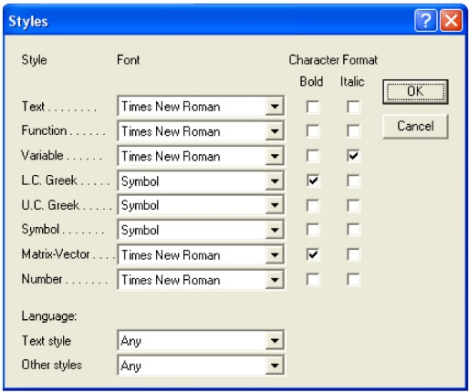
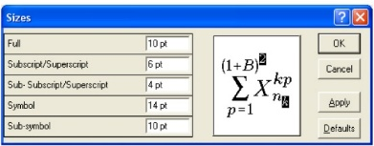
Fig. 1 Styles and sizes for equations
An example of an equation written in Equation Editor:
(1)
Paragraph format for equations are (Style Equation): left indentation, 6 pt before and after, equation is at position of centered tab at 4 cm, number of equation is at position of right tab at 8.25 cm. Refer to equations in the text as Eq. (1), or Eqs. (1) and (2), and similar.
The file may be saved as .doc or .docx file. Equations must be editable, i.e. they cannot be given as figures.

1.2. Illustrations: figures, photographs, line drawings, graphs (Styles Figure and Figure Title)
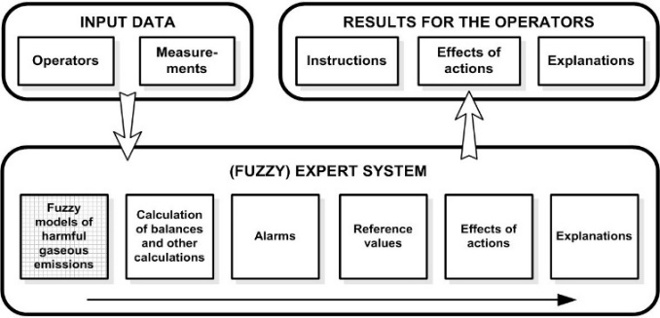
Fig. 2 Title of figure
All illustrations (figures, photographs, line drawings, graphs) should be numbered in series and all legends should be included at the bottom of each illustration. All figures, photographs, line drawings and graphs, prepared in electronic form, should be converted to TIFF or JPG (max quality) files, 300 dpi resolution. Figures, line drawings and graphs prepared using elements of MS Drawing or MS Graph must be converted in form of pictures and unchangeable. All illustrations should be planned in advance so as to allow reduction to 8.25 cm in column width. Please review all illustrations to ensure that they are readable. Refer to figures in the text as Fig. 1, or Figs. 1 and 2, and similar.

1.3. Tables
Table 1 Title of table (Style Table title)
System | Symbol
Without delay | +
Delay h = 1 | −
Delay h = N = 34 | *
All tables should be numbered with consecutive Arabic numbers. They should have descriptive captions at the top of each table and should be mentioned in the text.
Acknowledgement: The paper is a part of the research done within the project 1234567890. The authors would like to thank to the... (Style Acknowledgement).

References
(Samples given below)
Journal papers:

General form:
- Surname1, I., Surname2, I., …, year, Paper title, Journal Title, volume(issue), pp. page numbers, or article number, or doi (the option depends on the specific journal – check below)

Other forms of references are not acceptable.

If a journal uses page numbers as identifiers, use this form:
Blagojević, V., Milosavljević, Č., 2002, Application of digital sliding modes to synchronization of the work of two pneumatic cylinders, Facta Univesitatis Series Mechanical Engineering, 1(9), pp. 1275-1285.

If a journal uses article number as an identifier, use this form
Marinkovic, D., Zehn, M., 2019, Survey of finite element method-based real-time simulations, Applied Sciences, 9(14), 2775.

If a paper has been published on the Online First (Early Access) page and has not been assigned to an issue yet, use the DOI number in this form:
Moory Shirbani, M., Alavi, S., 2024, Multi-objective optimization and performance analysis of bimorph magneto-electro-elastic energy harvesters, Facta Universitatis Series Mechanical Engineering, https://doi.org/10.22190/FUME231102003S

A book (must include the publisher and the place):
Stojiljković, M., 2002, Logical synthesis of pneumatic control, Faculty of Mechanical Engineering, Niš, 376 p.

A conference paper (must include the year, preferably also the date, and the place)
Muralidhara, H.S., 1998, Variable structure systems - A Survey, Proc. Sixth International Drying Symposium IDS 1988, Versailles, K1. 71.

PhD thesis:
Polat, O., 1989, Optimization of a Steam Boiler, PhD Thesis, McGill University, Canada.

A report:
Perkin, R.M., 1999, Feature models in Virtual Product Development, Report ECRC/M1677, Capenhurst, England.

An internet link (must include the date of the last access):
www.link.com (last access: dd.mm.yyyy)

The predefined indentations are 0.5 cm for the reference number and 0.75 cm for the text. Make sure this is so in your paper as well. The numbers are aligned on the right hand side (at 0.5 cm, as given above).
Make sure all references are strictly formatted as per the template, i.e. as per examples listed above. If this is not the case, processing of your paper will be delayed. Reference elements (for instance, for a journal reference: authors, publication year, Paper title, Journal Title, volume(issue), pp. page-page) are separated by comma (do not use a dot). Do not use “et al.”, “and” or “&” in the list of authors. There should be no empty space between initials (check reference no. 5 above). Do not use capital letters where not appropriate (compare with the examples). The titles of journal references use small letters, and capital letters only where demanded by grammar. On the other hand, in the book tittles, all the main words start with a capital letter, but not the connecting words. The indentations and the style of numbering must be the same as in the examples provided above.

